**Internship at Skill Lync**

**Animated Responsive Food and Restaurant Website Design**

**By M. Suganya**

**INTRODUCTION**

**1.Overview**

Basics of HTML and CSS along with building a project which will be a complete responsive food and Restaurant website design page website. This is a simple food and restaurant website design and inventory of products. This system was programmed through the use of visual studio code. This features is purchasing products of cashiering, flower product in best review of customers.

**2.Purpose**

Food and Restaurant website design using HTML& CSS . I create in Just using HTML and CSS. This Is Very Easy to create this flower Website Design using HTML. After Creating the File I make the website Structure Using HTML And Design The Site Using cascading style sheets "CSS". I Make Five Sections, the first section is the home section, the second is about section, the third is products section, and fourth is the review section, fifth is a contact section . last is the footer section. After Making Structure and Designing.

**3.Flowchat**

menu

about

home

Flower website design

order

popular

gallary

**4.System Design**

**4.1 Home**

First have a look at the HTML components that create each section of this homepage. The picture below shows different HTML elements with its name that gives you a rough idea of how to create the HTML structure of the home page. The main section contains almost everything that you want to show on the homepage so it is also bigger than any other section. we are just using the about fresh flowers, shop now. From the image, you can get a rough idea of the structure of the main section. We have created the HTML part then style the elements using CSS. To select the element to style using CSS SELECTOR. We are going to use CSS FLEXBOX to align the elements horizontally and vertically.

**4.2 About**

The **about** page contains insightful information about the website. It contains information about the purpose of the website, why we use?, learn more details about the flower website design. This page is widely used especially in the flower website. The about us page may contain some heading text, images,video. Wrap all the contents within  element and set the add some background color,width also. Style each component with CSS properties and use Font Awesome.

**4.3 Menu**

The menu is used to navigate the pages in the websites. The menu can be placed horizontally at the top of the page or vertically as a side menu. The fixed menu is those which remain fixed on the viewport. To create a fixed menu use position:fixed property. To fix it at the top use top: 0. We can add margins to avoid overlay to other contents. Let's create a horizontal navigation menu and style it with some CSS properties.

**4.4 Popular**

The popular page include many foods display on the image. Also include the added to cart button. And price also mentioned. Both of them include css color animated using flexbox design. So, popular is the latest products.

**4.5 Gallary**

Gallary is created many images as per requirement. And also animated these all images.we will create a full width image gallery that will fit in the images of different aspect ratios. It will also responsively resize to suit smaller devices making it mobile friendly.

**4.6 Order**

Order page is the ordering the food. And the contact, name, password, address, phone no these are all the created form using order now button. Then add css and animated image also included.

**Hardware and Software Requirement**

**5.1 Hardware Required**

Processor: 11th Gen Intel(R) Core(TM) i3-1115G4 @ 3.00GHz 3.00 GHz

RAM:8GB

Input Devices : Keyboard, Mouse

Output Devices : Monitor

**5.2 Software Required**

**Operating System**: Windows 11

**Front end:** Visual studio code, HTML, CSS, JS

**Visual studio code**

Visual Studio Code is a lightweight but powerful source code editor which runs on your desktop and is available for Windows, macOS and Linux. It comes with built-in support for JavaScript, TypeScript and Node.js and has a rich ecosystem of extensions for other languages and runtimes (such as C++, C#, Java, Python, PHP, Go, .NET). Visual Studio Code for the Web provides a free, zero-install Microsoft Visual Studio Code experience running entirely in your browser, allowing you to quickly and safely browse source code repositories and make lightweight code changes.

**HTML**

HTML standards for Hyper Text Markup Language, which is the structural description of contents of a file. It is the arrangement of text, image and other multimedia contents on the display. HTML was developed with the intent of defining the structure of documents like headings, paragraphs, lists, and so forth to facilitate the sharing of scientific information between.

**CSS**

CSS is basically a style sheet language which presents a document written in a markup language as like as HTML. It separates contents like layout colors, fronts and improves control over the contents. CSS handles the look and feel part of a web page. Using CSS, you can control the color of the text, the style of fonts, the spacing between paragraphs, how columns are sized and laid out, what background images or colors are used, layout designs,variations in display for different devices and screen sizes as well as a variety of other effects. CSS is easy to learn and understand but it provides powerful control over the presentation of an HTML document. Most commonly, CSS is combined with the markup languages HTML or XHTML.

**JS**

JavaScript, also known as JS, is one of the scripting (client-side scripting) languages, that is usually used in web development to create modern and interactive web-pages. The term "script" is used to refer to the languages that are not standalone in nature and here it refers to JavaScript which run on the client machine. In other words, we can say that the term scripting is used for languages that require the support of another language to get executed. For example, JavaScript programs cannot get executed without the help of [HTML](https://www.javatpoint.com/html-tutorial) or without integrated into HTML code. [JavaScript](https://www.javatpoint.com/javascript-tutorial) is used in several ways in web pages such as generate warning messages, build image galleries, DOM manipulation, form validation, and more.

**6.Output Screenshot**

**6.1 Home**

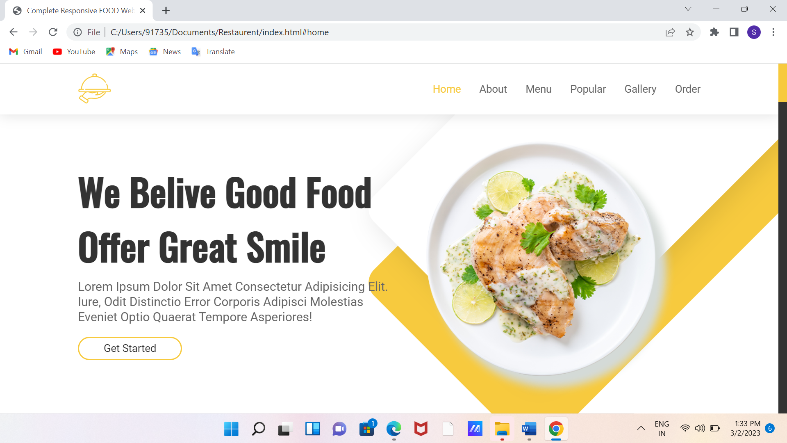

**6.2 About**

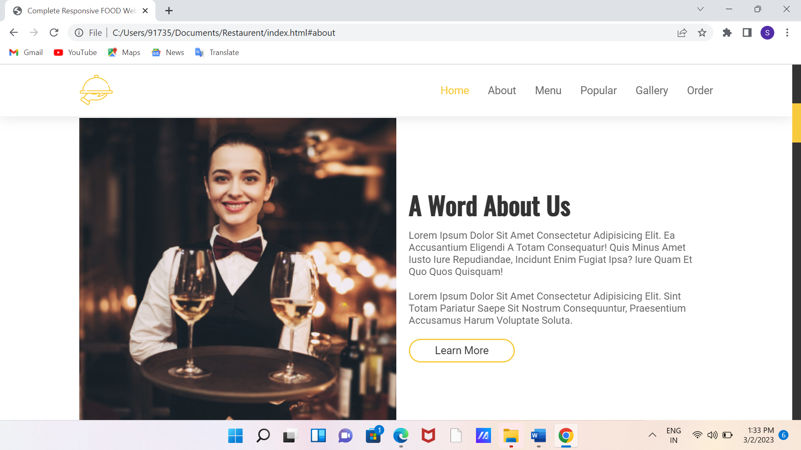

**6.3 Menu**

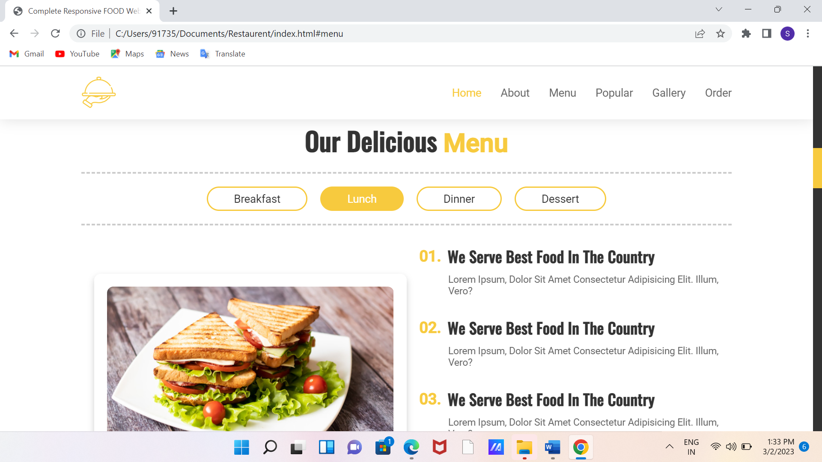

**6.4 Popular**

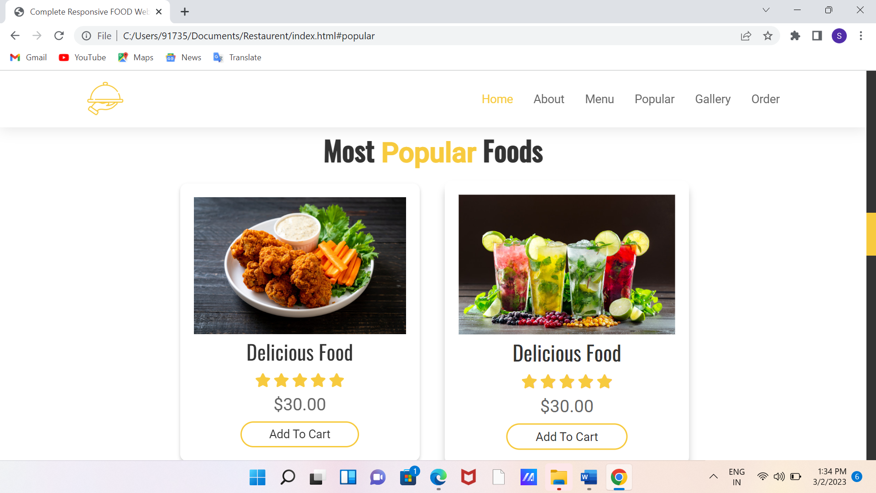

**6.5 Gallary**

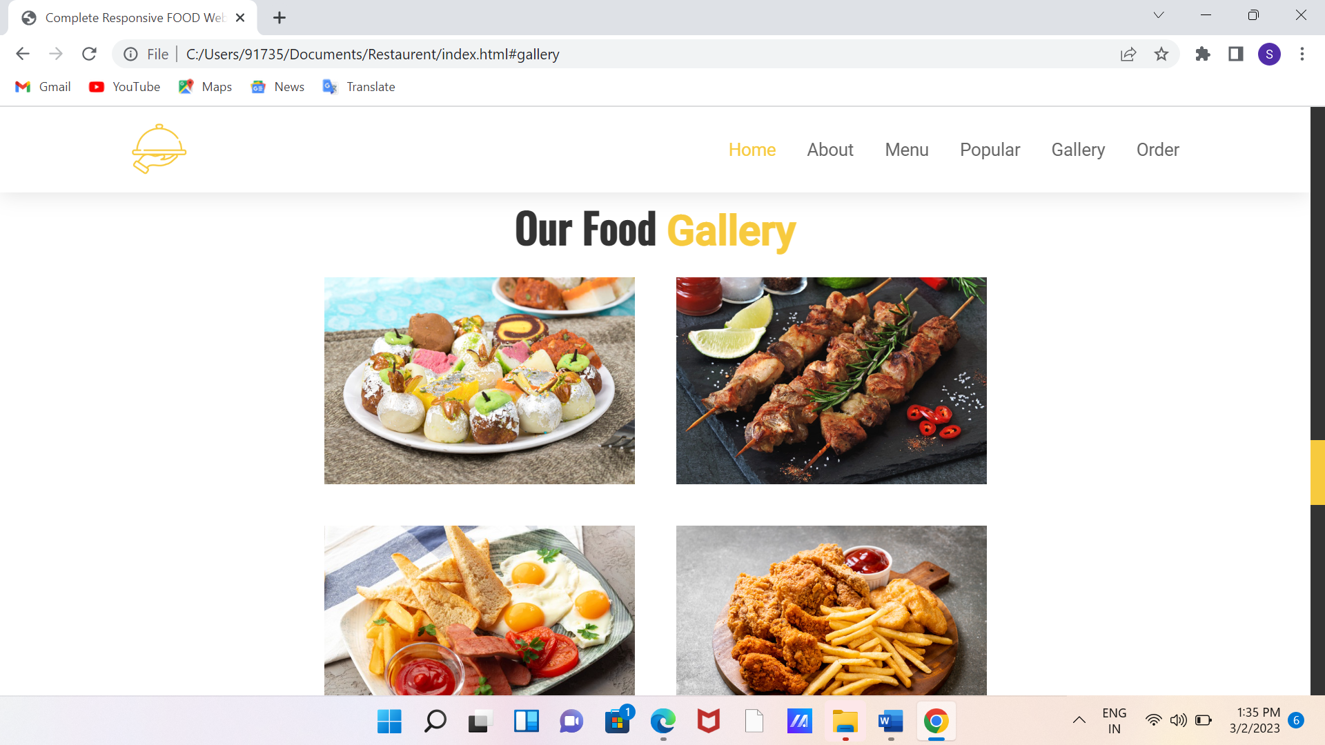

**6.6 Order**

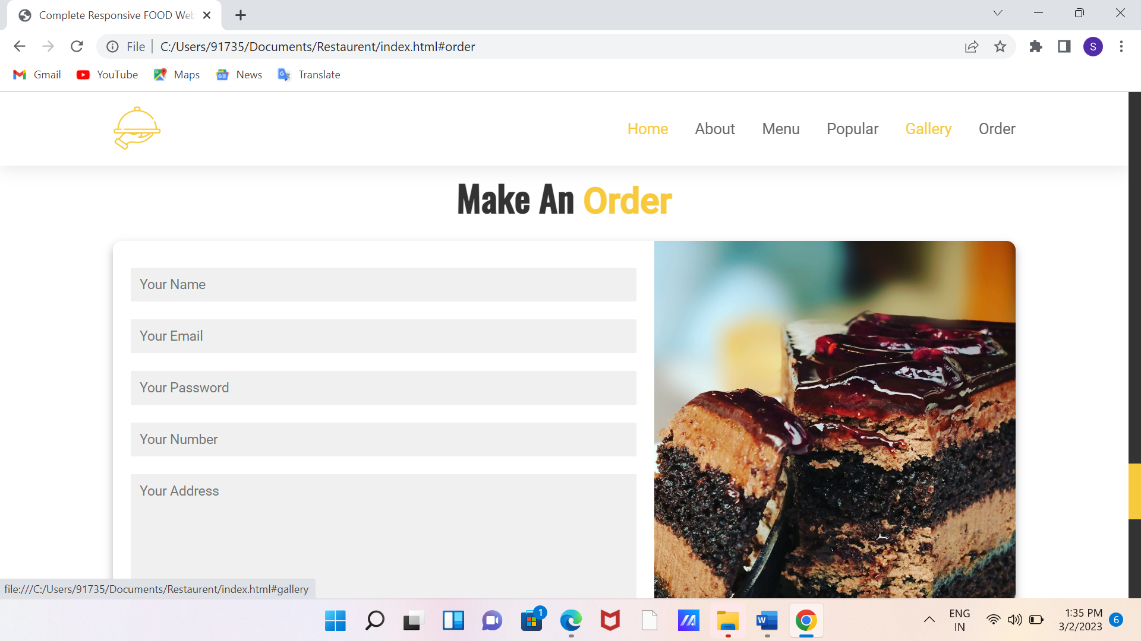

**Conclusion**

This concludes the create Food and Restaurant website design using HTML& CSS, JS . design which I create in Just using HTML and CSS and JS. This food and flower Website Design using HTML. After Creating the File I make the website Structure Using HTML And Design The Site Using cascading style sheets "CSS". created webpage simple flower website using html&css. After js we have include message. In using css animated function create excitable webpage.